EduGenie
Google Gemini Powered Learning Assistant

Project Description
EduGenie is a lightweight AI-powered educational assistant that simplifies learning through generative AI.
Designed for students of all academic levels, EduGenie enables users to:
- Ask questions and receive smart, concise answers
- Understand complex concepts through simplified explanations
- Generate quizzes from topics or text
- Receive personalized learning recommendations
- Summarize large educational passages
Scenarios
Scenario 1: A student wants to know about oceans and rivers and asks, “Which is the largest ocean?”
Scenario 2: A student wants to check her understanding of “The Pythagoras Theorem” and clicks “Generate Quiz.”
Scenario 3: A learner exploring SQL requests a structured learning path from beginner to advanced topics.
Pre-Requisites
- Python 3.10+
- FastAPI Framework
- HTML & CSS
- Google Gemini API Key
- Uvicorn (ASGI Server)
- Jinja2 (HTML Templating Engine)
Project Workflow
Milestone 1: Model Selection and Architecture
Gemini 1.5 Pro (via API) is used for Q&A, summarization, quiz generation, and learning paths.
LaMini-Flan-T5-783M (local) is used for concept explanation.
Milestone 2: Core Functionalities Development
Explanation Module: Uses LaMini-Flan-T5 to provide concise, context-aware explanations in simple language.
QnA Module: Uses Gemini 1.5 Pro for general knowledge and academic question-answering.
Quiz Module: Generates three multiple-choice questions with four options each and returns structured JSON.
Summary Module: Summarizes long paragraphs into concise, easy-to-understand versions.
Learning Path Module: Generates personalized learning paths from beginner to advanced topics with useful resources.
Backend API with FastAPI
RESTful endpoints are defined for each module:
- /qa
- /explain
- /quiz
- /summarize
- /learn/recommendations
Milestone 3: Frontend Development
The web interface contains a task dropdown (Explain, QnA, Quiz, Summary, Recommend Path), a text area for user input, and a submit button. The interface is styled for responsive use.
Form submission sends a POST request to the FastAPI backend and the result appears below the input box in real time.
Milestone 4: Deployment
Activity 4.1: Run Locally
Run locally with: uvicorn main:app --reload
Application access: http://127.0.0.1:8000
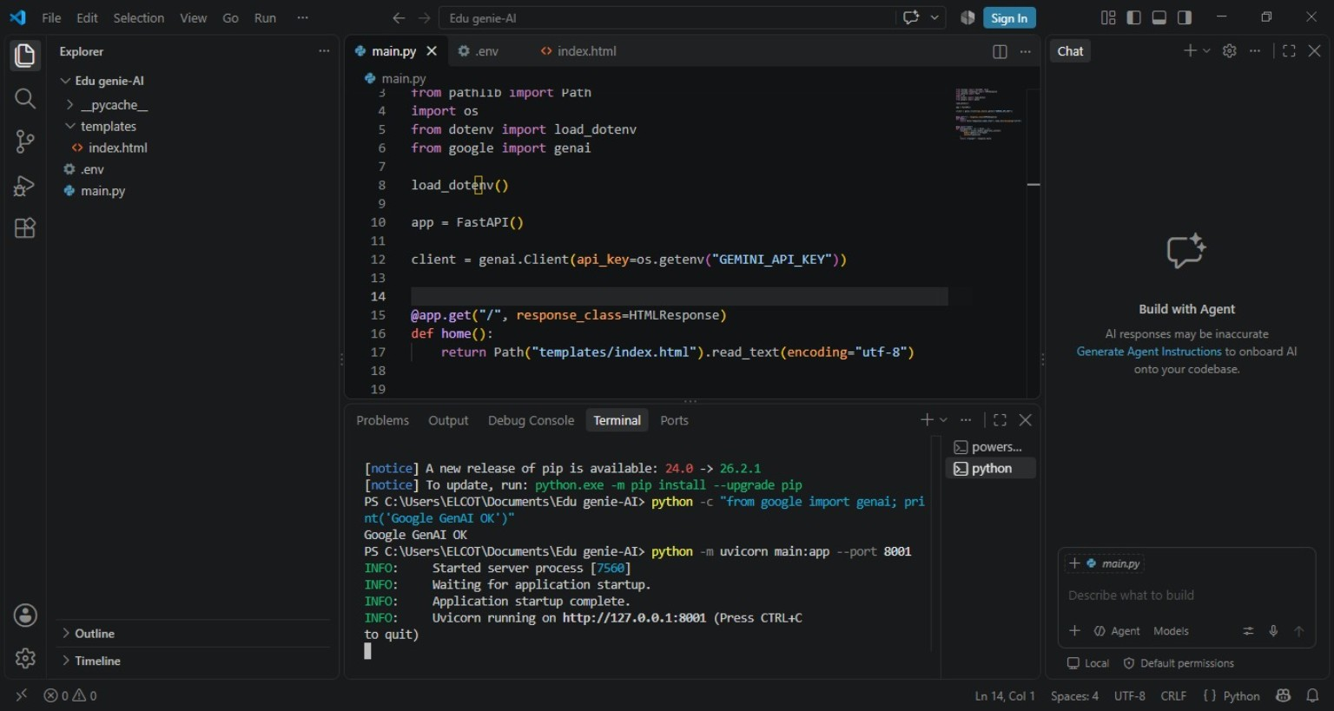
Figure: EduGenie project running in Visual Studio Code with the local application URL.
Activity 4.2: Functional Testing
- Ask a question
- Get an explanation
- Generate a quiz
- Summarize content
- Get a personalized learning plan
Exploring EduGenie
- Asking questions
- Explanation of any topic
- Summarising long paragraphs
- Generating quizzes
- Guiding with learning recommendations from beginner level to advanced level
Conclusion
EduGenie has been developed as a robust and accessible AI-powered educational assistant that integrates cloud-based intelligence with an intuitive web interface. It supports self-learners and educational use by simplifying complex concepts, providing question-and-answer interactions, generating quizzes, summaries, and personalized learning paths.
The project achieved milestones in AI integration, user experience design, and content adaptability. Key development challenges included accuracy of AI-generated responses, device performance, personalization, testing, prompt engineering, cloud integration, user-centric design, and data privacy.
Future enhancements described in the report include voice interaction, multilingual support, a mobile application, progress tracking dashboards, gamification, adaptive learning paths, group study support, teacher/parent dashboards, LMS integration, image/PDF input, real-time synchronization, and smart notifications.
Project Structure
- EduGenie/ — Project folder
- main.py — FastAPI app
- explanation_module.py — Concept explanation logic
- qna.py — Question answering
- quiz_module.py — Quiz generation
- summary_module.py — Summarization
- learning_path.py — Learning recommendations
- templates/index.html — HTML frontend
- static/style.css — Styling
- requirements.txt — Python dependencies
Submitted by: Tella Divya Sree Mentor: Siri Date: 11/04/2025

